**THE DESTRUCTION OF THE AMAZON - CASE STUDY**

**SUBMITTED BY ADITYA SINGH 2K19/EP/005**

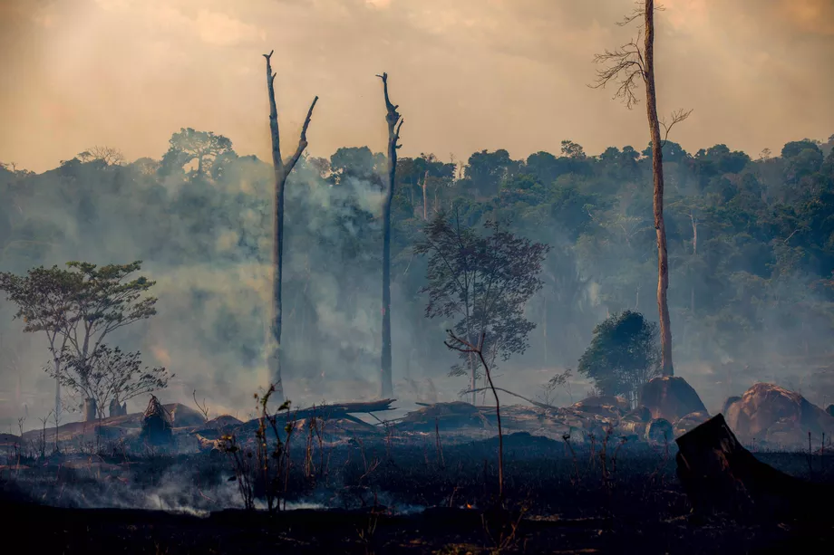

**Why is this a Big Deal ?**

The Amazon rainforest has been reduced by about 17% since the 1970s. Cattle ranchers, loggers, and farmers are mostly to blame for the deforestation, but the demand driving them comes from all around the world. Brazil's economy depends on agriculture, especially beef and soy, which is grown on cleared land in the Amazon. Today, president Jair Bolsonaro, is weakening the environmental protections there in order to give agriculture more power. This came to a head when, in summer 2019, more than 30,000 wildfires burned in the Amazon, sparking worldwide outrage.

**Amazon is Burning**

An unprecedented number of fires raged throughout Brazil in 2019, intensifying in August. It is reported that there were more than 80,000 fires, the most that it had ever recorded. It was a nearly 80 percent jump compared to the number of fires the country experienced over the same time period in 2018. More than half of those fires took place in the Amazon.

The number of blazes decreased in September, after president Jair Bolsonaro bowed to mounting pressure to address the flames and announced a 60-day ban on setting fires to clear land. Some exceptions were made for indigenous peoples who practice subsistence agriculture and those who’ve received clearance by environmental authorities to use controlled burning to prevent larger fires.

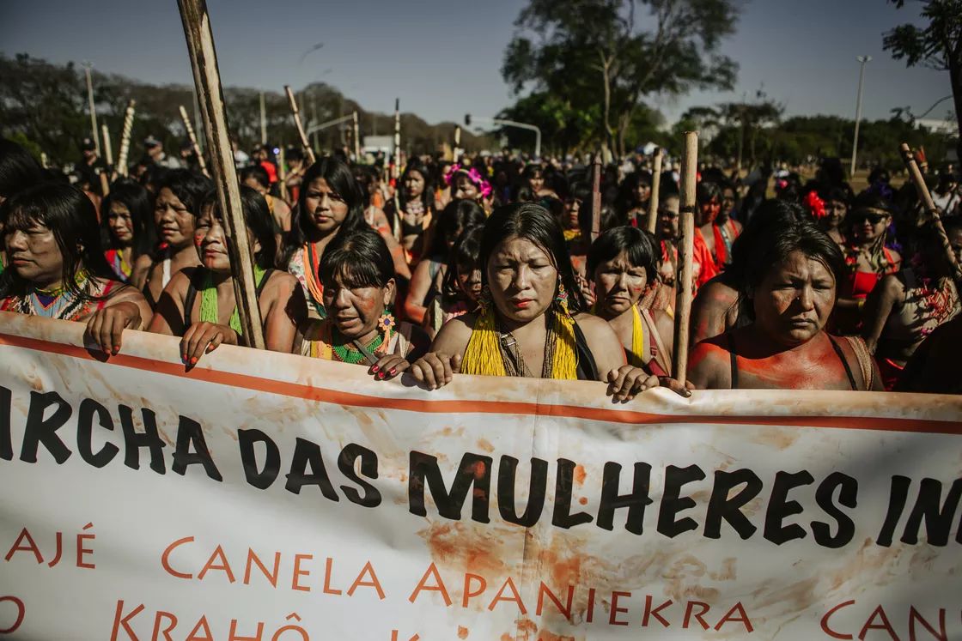

**A Politically Hot Topic**

When Jair Bolsonaro was campaigning for office as a far-right candidate, he called for setting aside less land in the Amazon for indigenous tribes and preservation, and instead making it easier for industry to come into the rainforest. Since his election in October 2018, Bolsonaro put the Ministry of Agriculture in charge of the demarcation of indigenous territories instead of the Justice Ministry, essentially “letting the fox take over the chicken coop”. His policies have been politically popular among industry and agricultural interests in Brazil, even as they’ve been condemned by Brazilian environmental groups and opposition lawmakers. Hundreds of indigenous women stormed the country’s capital on August 13th to protest Bolsonaro’s environmental rollbacks and encroachment of development on indigenous lands. The hashtag #PrayforAmazonia blew up on Twitter.

**Why it’s been so lucrative to destroy Amazon**

Yet in the past year, deforestation and fires have surged, reversing years of decline. Several scientists are now raising the alarm that the Amazon is moving closer toward a dieback scenario, where enough of the forest is lost that the ecosystem as a whole could collapse.

Despite these risks, there are tremendous economic pressures behind the blazes. The vast majority of the fires burning in the Amazon right now were started by humans in service of mining, logging, and agriculture. After clearing an area of forest, fires are ignited by farmers using slash-and-burn techniques to help put nutrients in the soil for crops. Others use fires to clear low-level vegetation to more easily access trees and the soil. Fires are also used by illegal loggers and miners to drive indigenous people off their lands.

One of the biggest drivers of deforestation is cattle ranching. Brazil is now the world’s largest beef exporter. In 2018, these exports generated $6.7 billion for the country’s economy. Brazil is also the second-largest producer of soybeans in the world, and about 80 percent of the soy grown in the Amazon is used for animal feed. With China’s recent tariffs on US soybeans, China has increased its appetite for soybeans from Brazil.

**Tremendous Costs of its Destruction**

What happens in the Amazon rainforest has global implications, which is why some countries have taken a keen interest in preserving it. It absorbs carbon dioxide, but could become an emitter if it degrades too much. That makes preserving the Amazon a crucial tactic in combating global climate change.

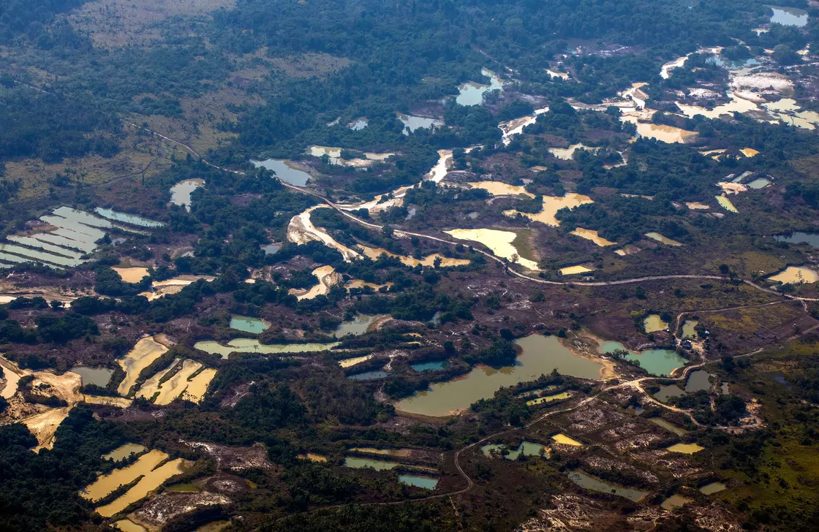

But there is only so much the forest can give before it collapses. About 17 percent of the Amazon has been lost, and if that rises to 20 to 25 percent, some scientists warn the forest will cross a tipping point and enter a dieback scenario. There won’t be enough vegetation to move moisture through the ecosystem, causing it to degrade into savanna.

Beyond being a global ecological catastrophe, the collapse would have huge economic consequences. The rain the forest generates also helps fill reservoirs for major cities and irrigate crops. It slows soil erosion and mitigates flooding. Products like Brazil nuts are mostly harvested from wild trees. The Amazon rainforest is also an important driver of tourism. And if it releases its carbon, it would exacerbate climate change, which has its own economic impacts ranging from rising sea levels to less nutritious crops.

In a study published last year in the journal Proceedings of the National Academy of Sciences, scientists in Brazil tabulated the costs of a dieback scenario. The social and economic damages from a dieback in the Amazon would cost between $957 billion and $3.59 trillion over 30 years.

**The Ultimate Solution to Protecting is Political**

Economic and political pressure from other countries can certainly help build the case for preserving the rainforest, but the most meaningful measures to protect the Brazilian Amazon will have to come from Brazil’s leaders.

Brazil has actually made huge strides in curbing deforestation and fires in the rainforest in the recent past. Between 2005 and 2014, deforestation in the Brazilian Amazon declined by 70 percent due to improved enforcement of environmental protections, international funding mechanisms, pressure from activists, and more efficient farming and ranching. These measures cost the Brazilian government between $308 and $923 per hectare of avoided deforestation. During the same time, Brazil’s economy grew, 29 million people were lifted out of poverty, and income inequality decreased.

However, legal protections for the Amazon rainforest started being weakened after then-President Dilma Rousseff, who placed a lower priority on the environment than her predecessor, came to office in 2011. As economic growth began to slow and international demand for beef and soy rose, deforestation

increased.And for the remaining environmental protection laws, the problem is enforcement. 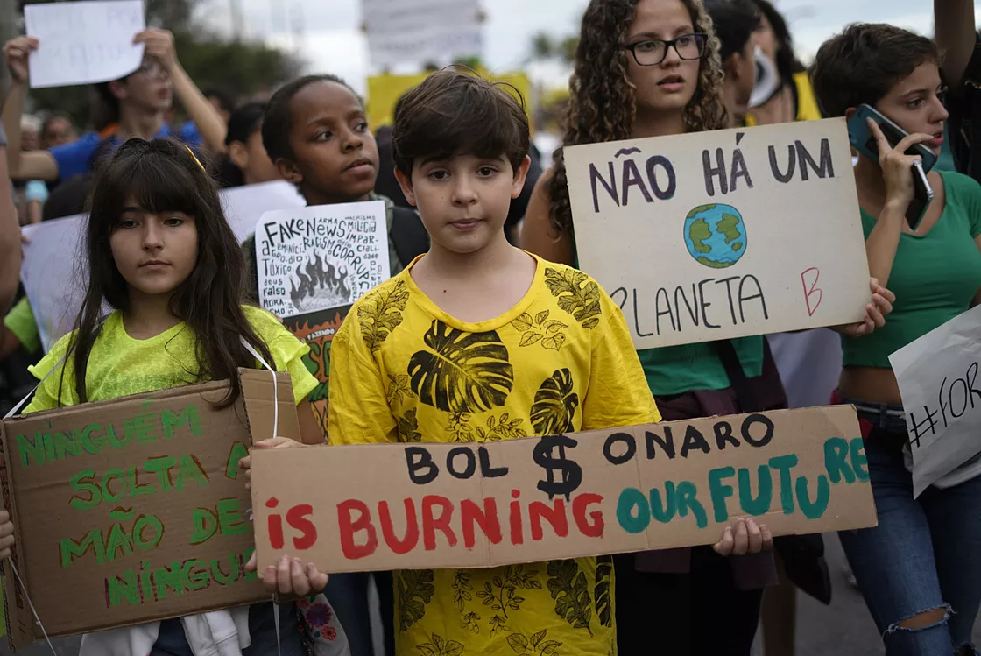

Even in the best of circumstances with a government that makes protecting the Amazon a priority, it’s difficult and expensive to police vast, remote, sparsely populated areas across difficult, densely forested terrain. That’s why the Amazon has become a smuggling route for illegal drugs.

With a government in place that wants to harness the rainforest and the resources within it for economic gain, it’s not too surprising that deforestation has increased.

Brazilians, now confronted with the impacts of the Amazon fires, have started to protest the exploitation of the rainforest, shocked by the blackened skies over the country. Demonstrations took place in major cities across the country this week. Opposition lawmakers have called for investigations of the causes of the fires.